Langfuse – EVALUATOR Troubleshooting
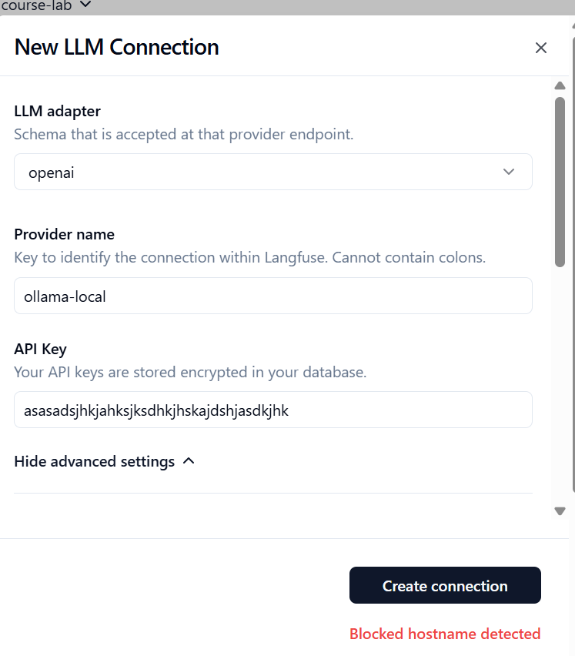
It says blocked hostname detected. Is there a whitelisting that needs to be done somewhare?
Yes, there are explicit environment variables you need to configure to whitelist private IPs and hostnames for custom LLM connections.
By default, Langfuse includes SSRF (Server-Side Request Forgery) protection that blocks connections to internal or private network addresses, such as localhost, host.docker.internal, or private IP ranges.
To bypass the "Blocked hostname detected" or "Blocked IP address detected" errors, you need to add the following variables to your langfuse-web and langfuse-worker environments in your docker-compose.yml:
- LANGFUSE_LLM_CONNECTION_WHITELISTED_HOST: A comma-separated list of hostnames to trust.
  - Example: LANGFUSE_LLM_CONNECTION_WHITELISTED_HOST=localhost,host.docker.internal
- LANGFUSE_LLM_CONNECTION_WHITELISTED_IPS: A comma-separated list of individual IPs to trust.
  - Example: LANGFUSE_LLM_CONNECTION_WHITELISTED_IPS=127.0.0.1,::1,172.17.0.1
- LANGFUSE_LLM_CONNECTION_WHITELISTED_IP_SEGMENTS: A comma-separated list of CIDR ranges to trust.
  - Example: LANGFUSE_LLM_CONNECTION_WHITELISTED_IP_SEGMENTS=127.0.0.0/8,172.16.0.0/12
Note: Do not use LANGFUSE_UNSAFE_TRUSTED_PRIVATE_IPS. While it appears in some older documentation and container environments, it is no longer implemented for LLM provider connections in newer Langfuse versions.
How to apply this for Docker Desktop
If you are trying to connect to a local Ollama instance on Mac or Windows using host.docker.internal, you should update your docker-compose.yml to include the LANGFUSE_LLM_CONNECTION_WHITELISTED_HOST variable:
YAML
services:
langfuse-server: # Or langfuse-web
# ... your existing config ...
environment:
# ... your existing env vars ...
- LANGFUSE_LLM_CONNECTION_WHITELISTED_HOST=host.docker.internal,localhost
extra_hosts:
- "host.docker.internal:host-gateway"

langfuse-worker:
# ... your existing config ...
environment:
# ... your existing env vars ...
- LANGFUSE_LLM_CONNECTION_WHITELISTED_HOST=host.docker.internal,localhost
extra_hosts:
- "host.docker.internal:host-gateway"
After saving the file, restart your containers:
Bash
docker compose down
docker compose up -d
Once the containers restart, you should be able to create the connection in the Langfuse UI using [http://host.docker.internal:11434/v1](http://host.docker.internal:11434/v1) without hitting the blocked hostname error

